Multi-Domain (SAN) SSL/TLS certificate
# Source: AI Source: Provided by: [Data Path: Persons Table -> ID Column: 1, Name_En Column: Motasem Essam] -> From: [ChatGPT] on [1/18/2026]
A Multi-Domain (SAN) SSL/TLS certificate is a certificate that secures multiple different domain names (and optionally subdomains) using one single certificate.
SAN stands for Subject Alternative Name.

🔐 What a Multi-Domain (SAN) Certificate Is
# Source: AI Source: Provided by: [Data Path: Persons Table -> ID Column: 1, Name_En Column: Motasem Essam] -> From: [ChatGPT] on [1/18/2026]
- One certificate → many domains
- Each domain is listed explicitly in the certificate
- Flexible: add or remove domains as needed
Example SAN list
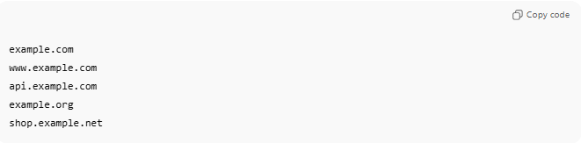
example.com
www.example.com
api.example.com
example.org
shop.example.net
All of the above are protected by one certificate.

🛠️ How It Works
# Source: AI Source: Provided by: [Data Path: Persons Table -> ID Column: 1, Name_En Column: Motasem Essam] -> From: [ChatGPT] on [1/18/2026]
- Certificate is issued with multiple SAN entries
- Browser checks if the requested domain matches any SAN
- If matched → HTTPS connection is trusted
- Encryption works the same as single-domain certificates

📍 Where SAN Certificates Are Used
# Source: AI Source: Provided by: [Data Path: Persons Table -> ID Column: 1, Name_En Column: Motasem Essam] -> From: [ChatGPT] on [1/18/2026]
- Companies managing multiple domains
- SaaS platforms
- Load balancers & reverse proxies
- Cloud and microservices environments
- Email and API services

🧠 Types of SAN Certificates
# Source: AI Source: Provided by: [Data Path: Persons Table -> ID Column: 1, Name_En Column: Motasem Essam] -> From: [ChatGPT] on [1/18/2026]
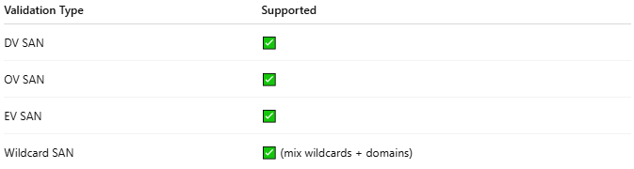
Validation Type | Supported
DV SAN | ✅
OV SAN | ✅
EV SAN | ✅
Wildcard SAN | ✅ (mix wildcards + domains)
Example:
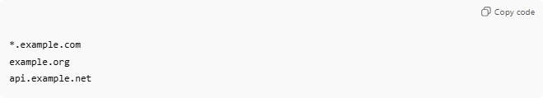
*.example.com
example.org
api.example.net

✅ Advantages
# Source: AI Source: Provided by: [Data Path: Persons Table -> ID Column: 1, Name_En Column: Motasem Essam] -> From: [ChatGPT] on [1/18/2026]
- One certificate for many domains
- Flexible and scalable
- Easier renewal and management
- Can mix domains and wildcards

⚠️ Disadvantages
# Source: AI Source: Provided by: [Data Path: Persons Table -> ID Column: 1, Name_En Column: Motasem Essam] -> From: [ChatGPT] on [1/18/2026]
- More expensive than single-domain certificates
- Private key compromise affects all domains
- Certificate size increases with many SAN entries

🔒 Best Practices
# Source: AI Source: Provided by: [Data Path: Persons Table -> ID Column: 1, Name_En Column: Motasem Essam] -> From: [ChatGPT] on [1/18/2026]
- Group domains with similar security requirements
- Protect the private key carefully
- Use separate certificates for high-risk domains
- Keep SAN list minimal and clean

🧠 Authentication Factor
# Source: AI Source: Provided by: [Data Path: Persons Table -> ID Column: 1, Name_En Column: Motasem Essam] -> From: [ChatGPT] on [1/18/2026]
- Something you have → SAN certificate + private key

🔍 Wildcard vs SAN (Quick)
# Source: AI Source: Provided by: [Data Path: Persons Table -> ID Column: 1, Name_En Column: Motasem Essam] -> From: [ChatGPT] on [1/18/2026]
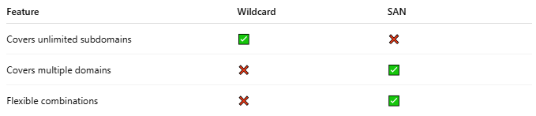
Feature | Wildcard | SAN
Covers unlimited subdomains | ✅ | ❌
Covers multiple domains | ❌ | ✅
Flexible combinations | ❌ | ✅

One-sentence summary
# Source: AI Source: Provided by: [Data Path: Persons Table -> ID Column: 1, Name_En Column: Motasem Essam] -> From: [ChatGPT] on [1/18/2026]
A Multi-Domain (SAN) certificate secures multiple different domains and subdomains with a single SSL/TLS certificate.

